**Deployment Manual**

**Project title: Bank Application**

**Team members:**

1. Ashwini sudhakar shinde (52076148)
2. Chithra Priya G(52076173)
3. Aiswarya K (52071463)
4. Puttaparthi Mounika (52072544)
5. Sudharsan V (52069902)
6. *The* ***GitHub Public Repository Link*** *for the Project* ***Bank Application***

**GitHub Link:** <https://github.com/chithrapriya98/BankApplicationProject.git>

1. *The* ***GitHub Public Repository Link*** *for the Project* ***Bank Application***

GitBash 🡪 We are using GitBash for working in the GitHub

STEP 1: Download the GitBash in your system

STEP 2: Create an empty workspace for the git project to be cloned (optional)

STEP 3: Open GitBash 🡪 use the command cd <path of the directory you want to clone the project with ‘/’ instead of ‘\’>

STEP 4: Now, use command “git clone <git repository URL >

[ The Git Hub project is cloned in the developer system]

**(sample)**

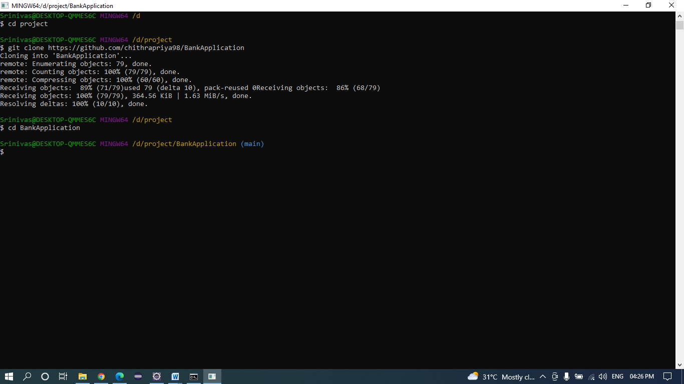

STEP 5: **enter cd in git bash press tab button**

1. ***How to import Project in ECLIPSE IDE***

STEP 1: Go ECLIPSE WORKSPACE, **file**🡪**open project from file system**

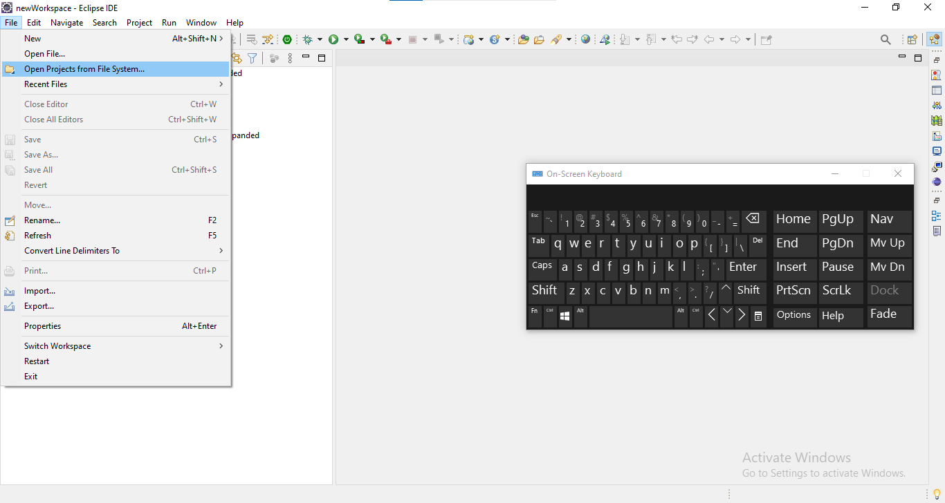

STEP 2: Then go to your workspace folder from directory 🡪 Select the cloned project from the directory 🡪 Finish

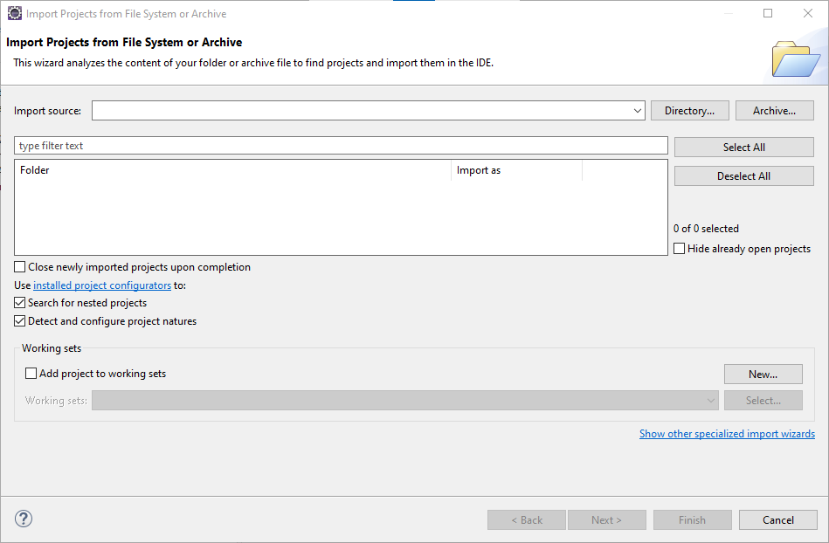

Following the above steps, you can import the project successfully in your ECLIPSE IDE workspace

***4.Changes to be done for the DB(Database)***

*ECLIPSE IDE*

STEP 1: Go to the project folder 🡪 Expand the folder 🡪 src/main/resources 🡪 application.properties

**Default Values for Database:**

Username : system

Password : system

STEP 2: Change the username and password for database🡪 To your own username and password

STEP 3: Save the application.properties file

STEP 4: Go to DB_Script folder and open database.sql file

**Create Table:**

Step 1: Copy the table queries and run in oracle (Run Command Line) and create the table.

Step 2: After running the application, create a new account to login into the application

***5.How to run Project in the ECLIPSE IDE***

*ECLIPSE IDE*

STEP 1: Go to the project folder

STEP 2: Then right click

STEP 3: Then go to Run As option

STEP 4: Click on Maven Clean

**Maven clean:**

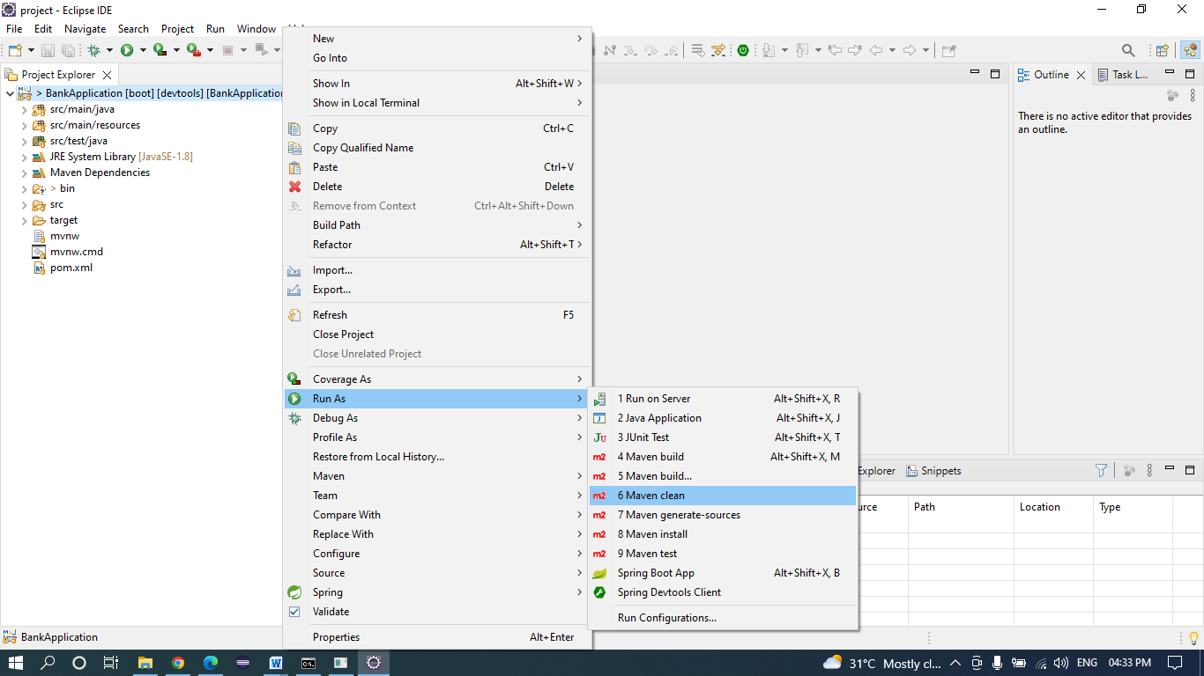

STEP 5: Check the Console, **BUILD SUCCESS** message should be displayed

STEP 6: Then, again go to Run As option

STEP 7: Click on **Maven Build**

**Maven Clean Success:**

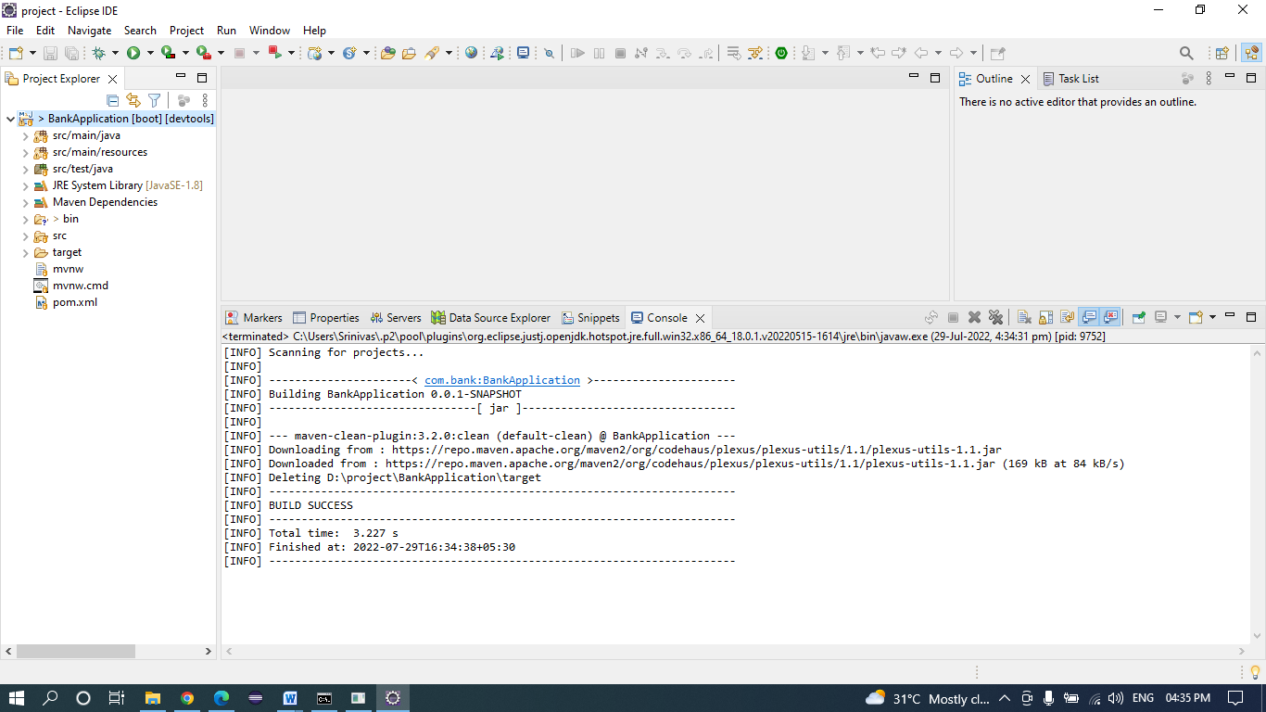

**Refresh:**

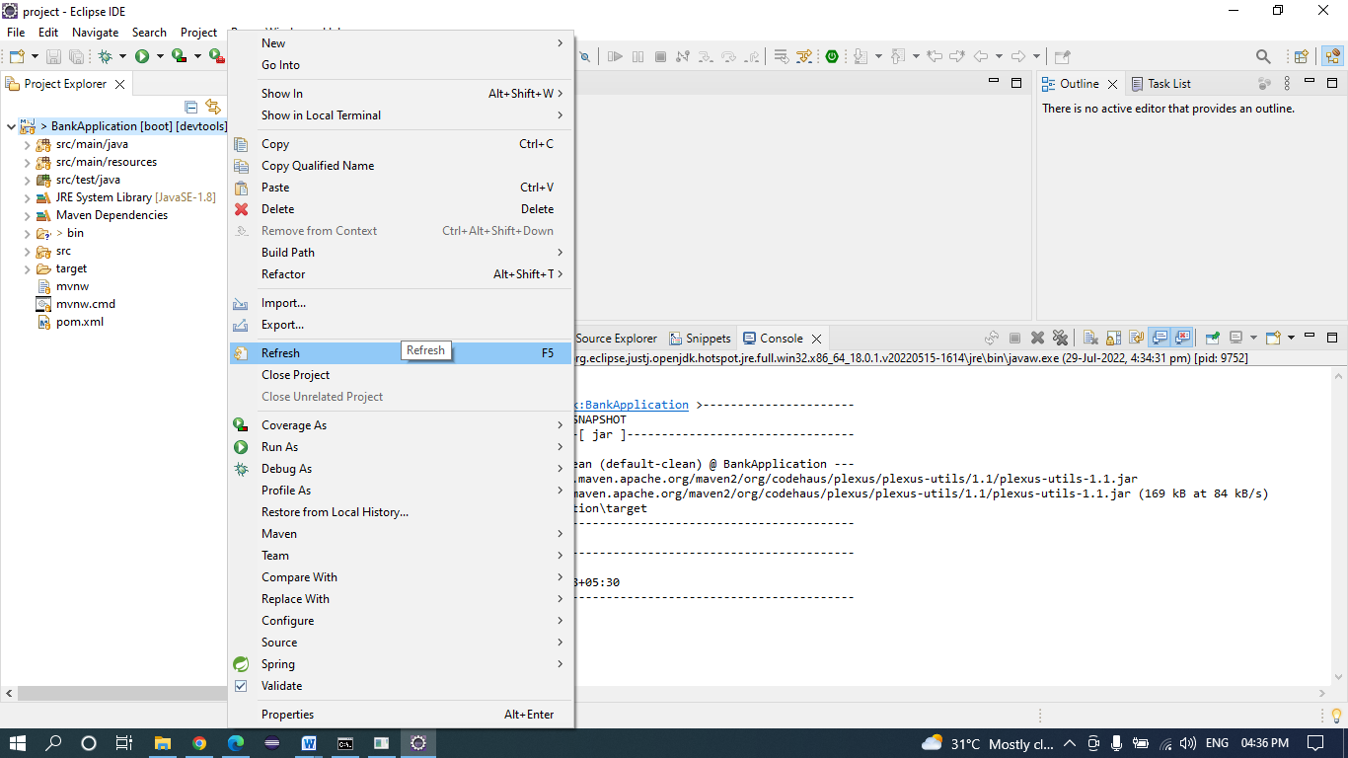

STEP 5: Click on Maven Build

**Maven Build:**

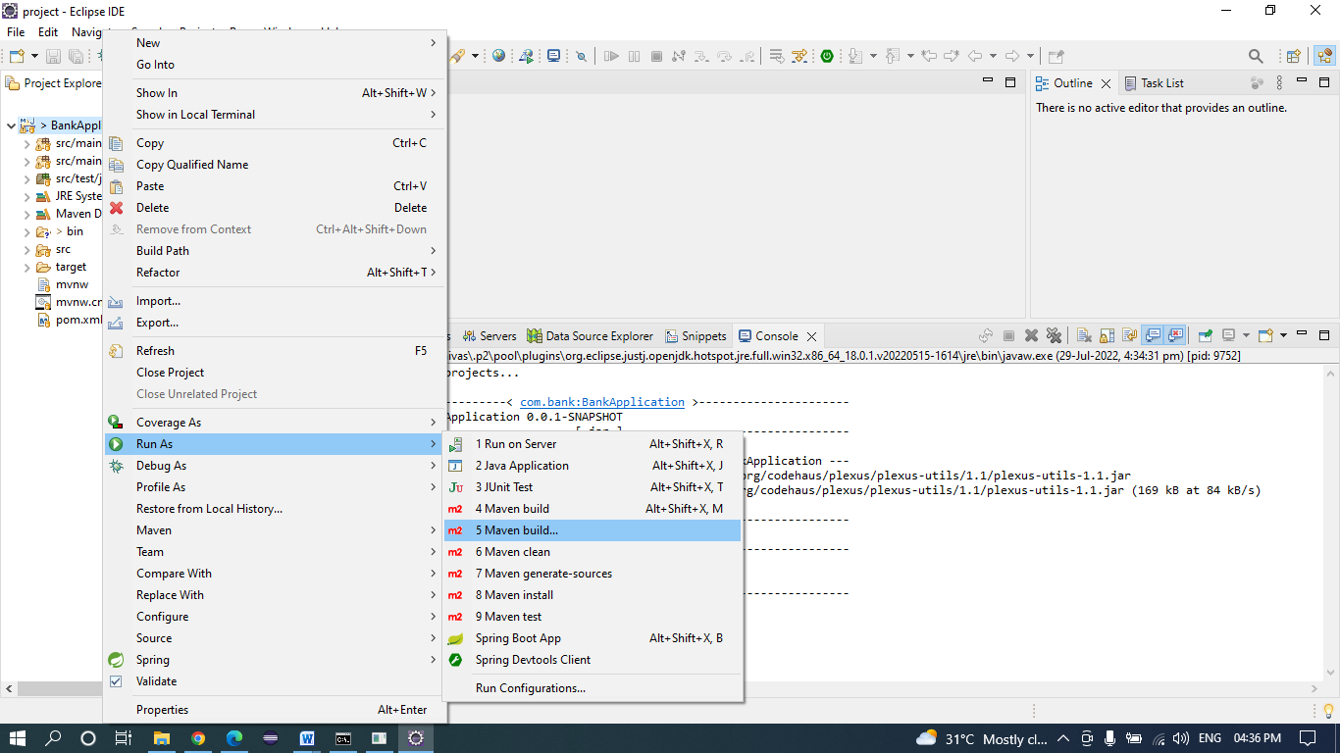

**Give Goal and apply then run:**

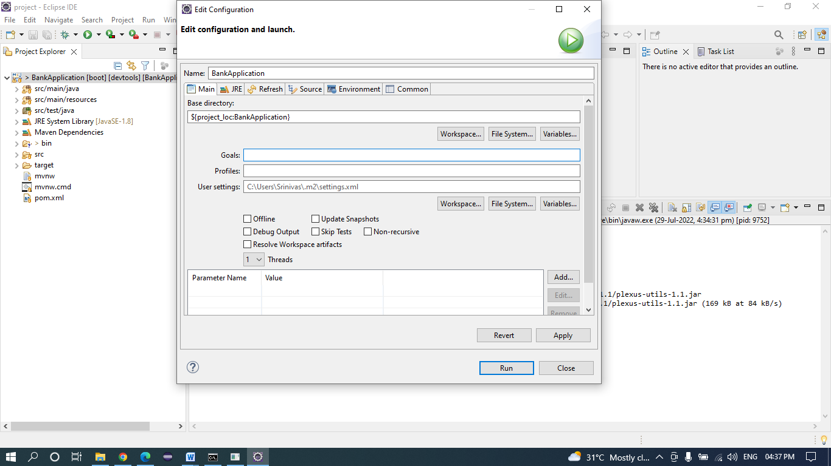

**Maven Build success:**

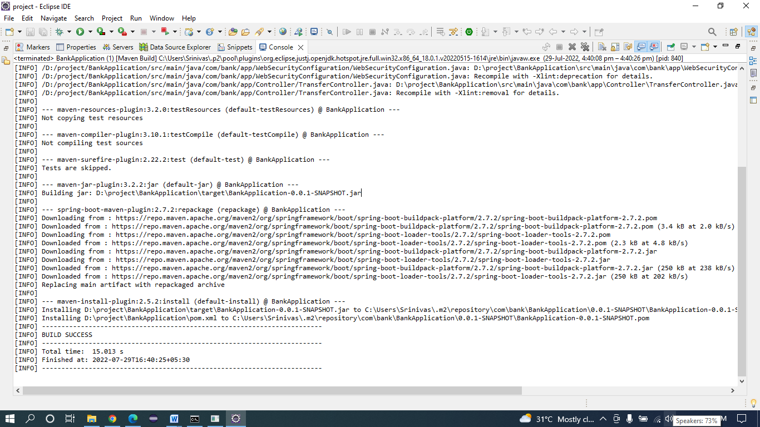

STEP 8: An Edit Configuration window will open; there a Goal option is found write **“clean install”** in the input space of goal. Also click on the **Skip Tests** checkbox. Then click on apply button, after that run button.

STEP 9: Check the Console, **BUILD SUCCESS** message should be displayed.

STEP 10: Go to src/main/java 🡪 com.bank.app (package) 🡪 BankApplication.java

STEP 11: right click on the BankApplication.java 🡪run as 🡪Spring Boot App

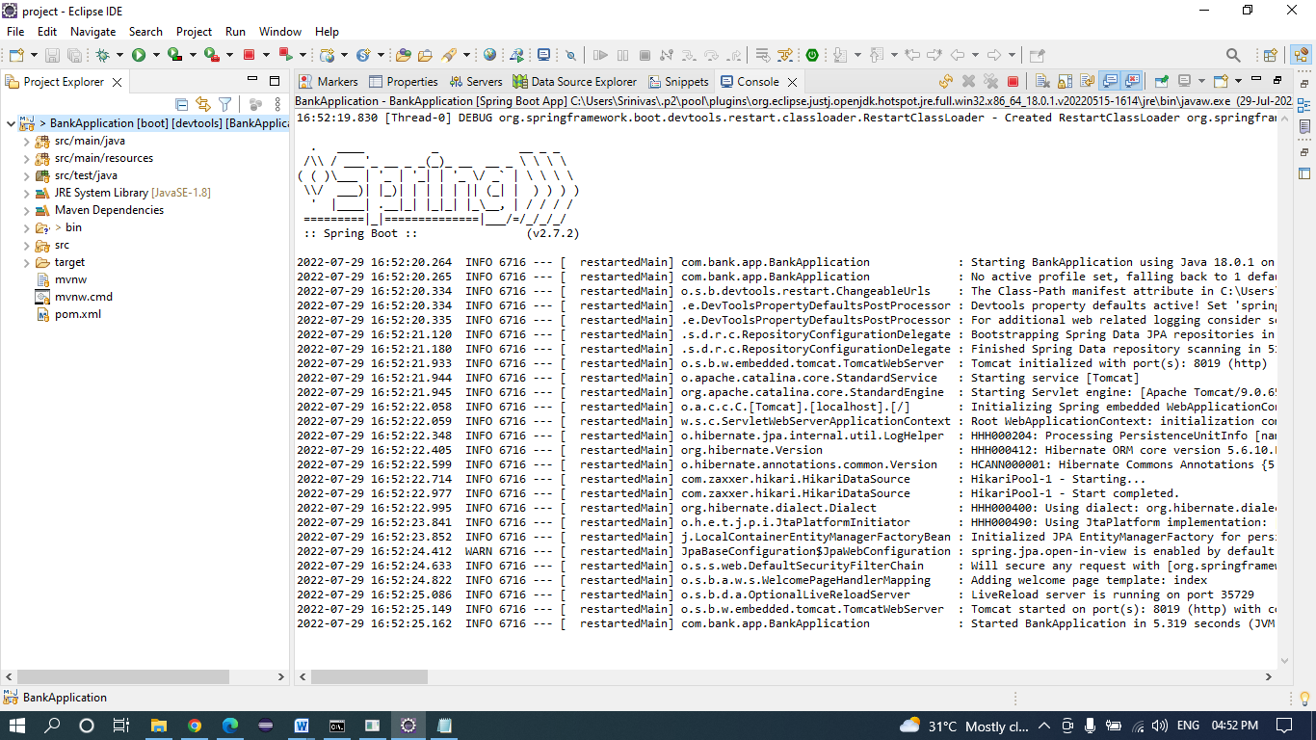

STEP 12: By default, the URL is set to display the index page. So, it will display a index page.

Note: Create new Account to login into application (by clicking signup in the index page or in login page there is create new account link).

***7.Other Details: -***

Tomcat Server port: 8019

***Version of Tech Stack:-***

* Spring Boot --- 2.7.2
* Java --- 8
* JDK – 1.8
* Oracle Database --- 11g